MAIN GENERAL PAGE
STEEL SIDING & SOFFIT
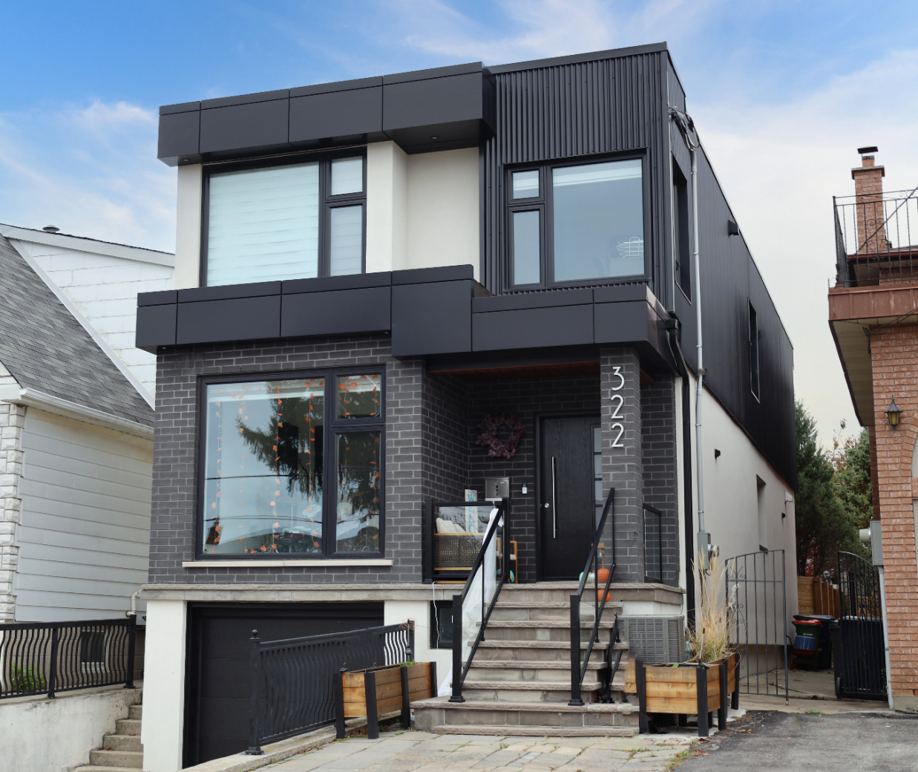
Industrial / Residential / Commercial / Agricultural
Durable, stylish, and cost-effective, metal siding panels offer a modern and long-lasting solution for residential and commercial projects. Made from high-quality steel, these panels provide excellent protection against harsh weather, fire, and pests while enhancing energy efficiency. Their low maintenance requirements and longevity make them a budget-friendly choice over time. With a variety of profiles, finishes, and colors available, metal siding delivers both aesthetic appeal and structural resilience, making it a smart investment for any building.
Curious about the advantages of steel siding? Visit our blog to explore the compelling reasons why this choice stands out for homeowners seeking durability and style.
Speak with an Expert Get personalized advice and expert guidance to achieve your project goals with confidence.

HIDDEN FASTENING (HF) SERIES MENU ICON (PREVIEW)

HIDDEN FASTENER (HF) SERIES Steel Siding & Soffit
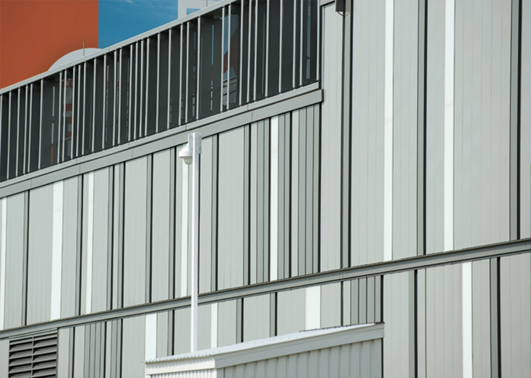
Hidden or Concealed fastening steel siding systems offer a clean, modern aesthetic with exceptional performance across residential, commercial, and industrial applications.... (Learn More / Expand)

HIDDEN FASTENER (HF) SERIES Steel Siding & Soffit (EXPANDED)
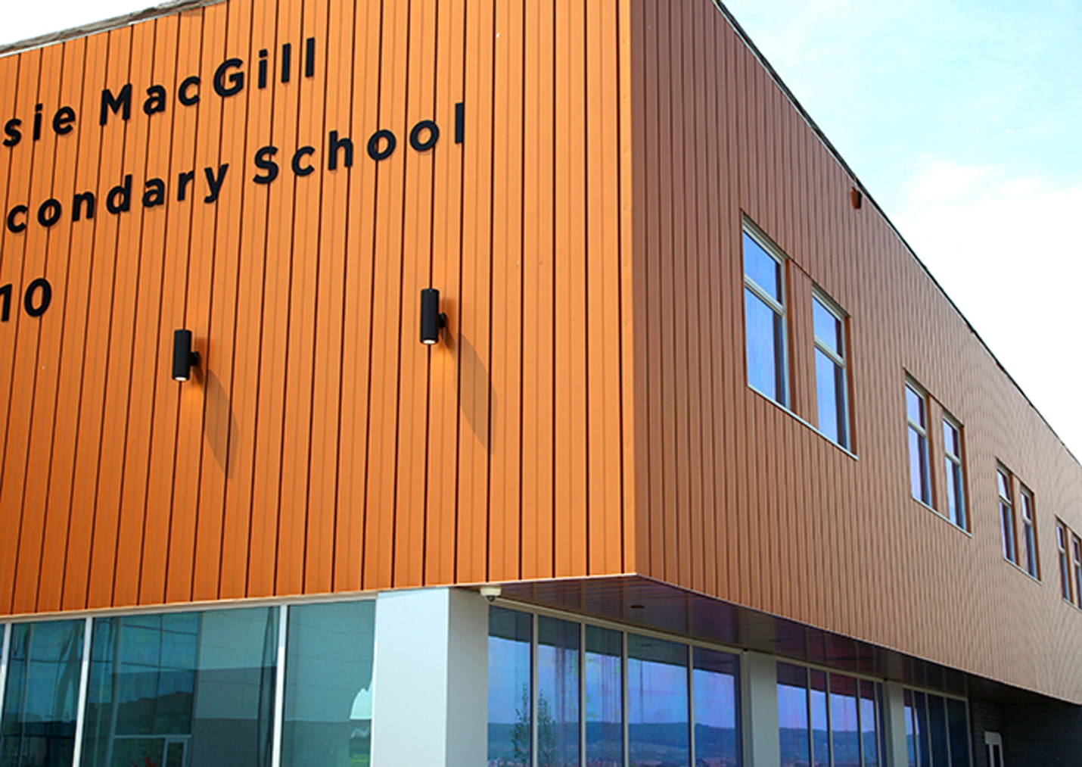
Expanded …By hiding fasteners behind interlocking panels, these systems provide a sleek, uninterrupted exterior surface that enhances visual appeal while improving long-term durability. The concealed design not only protects fasteners from weather exposure and corrosion but also reduces maintenance needs and increases lifespan. With a variety of profiles, colors, and finishes available, these systems deliver both architectural versatility and structural integrity—making them an ideal solution for projects demanding style, strength, and reliability
Curious about the advantages of steel siding? Visit our blog to explore the compelling reasons why this choice stands out for homeowners seeking durability and style.

DISTINCTION MENU ICON (PREVIEW)

Distinction Steel Siding & Soffit
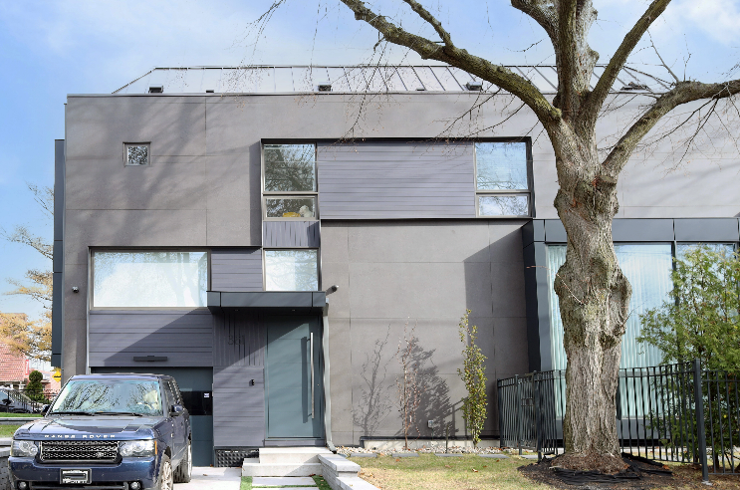
Distinction offers the elegant, stylish, and timeless appearance of authentic wood siding with the durability of premium steel... (Learn More / Expand)

DISTINCTION PAGE (EXPANDED)
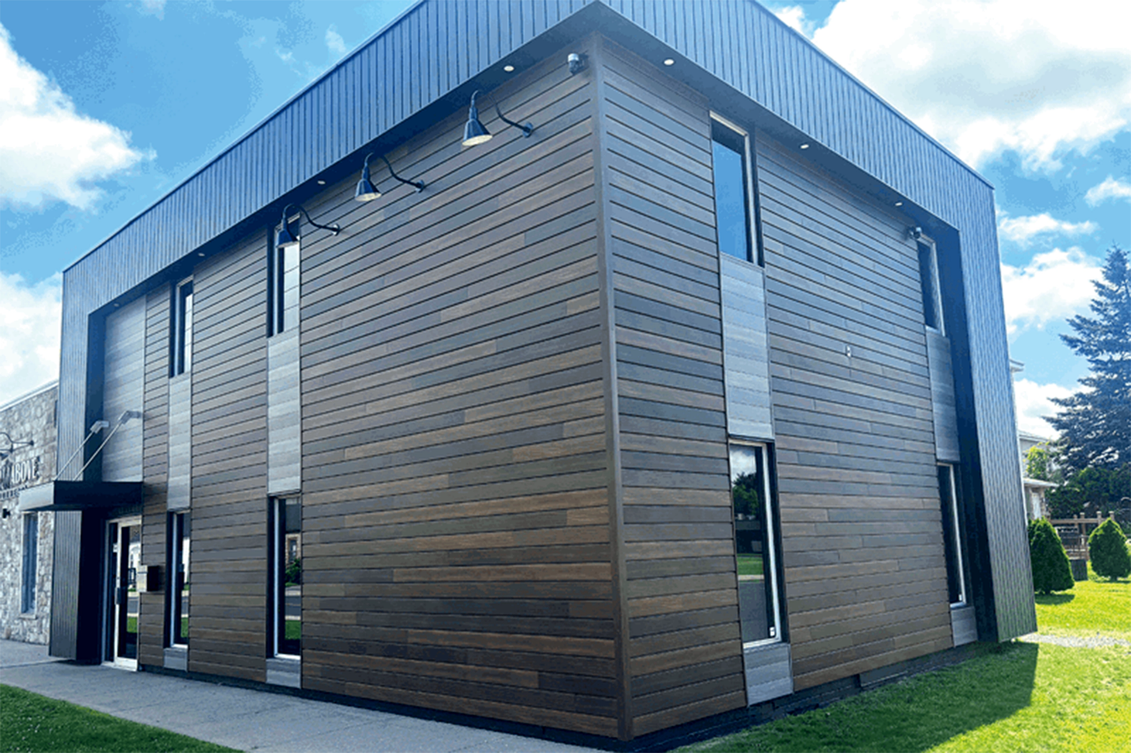
Expanded … Distinction offers the elegant, stylish, and timeless appearance of authentic wood siding with the durability of premium steel.
Designed to withstand the test of time, it combines a variety of colors and textures, allowing for a customized, balanced look. Crafted from 26-gauge G90 galvanized steel, Distinction features 12-foot standard panels ideal for both exterior and interior applications.

Distinction delivers both beauty and longevity. Its concealed fasteners ensure a seamless finish, with no visible seams or joints, and a coastal solution is also available, along with vented soffits for added versatility.
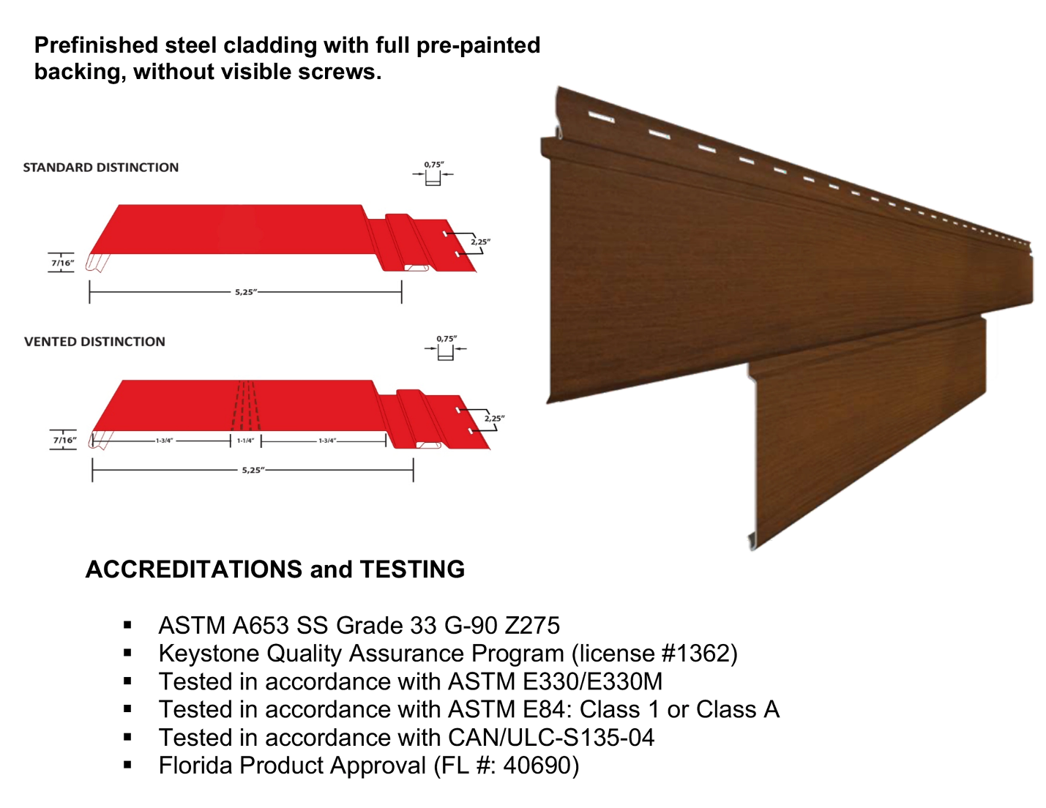

With a full line of matching accessories, UV-resistant paint to prevent discoloration and cracking, and the option for vertical or horizontal installation
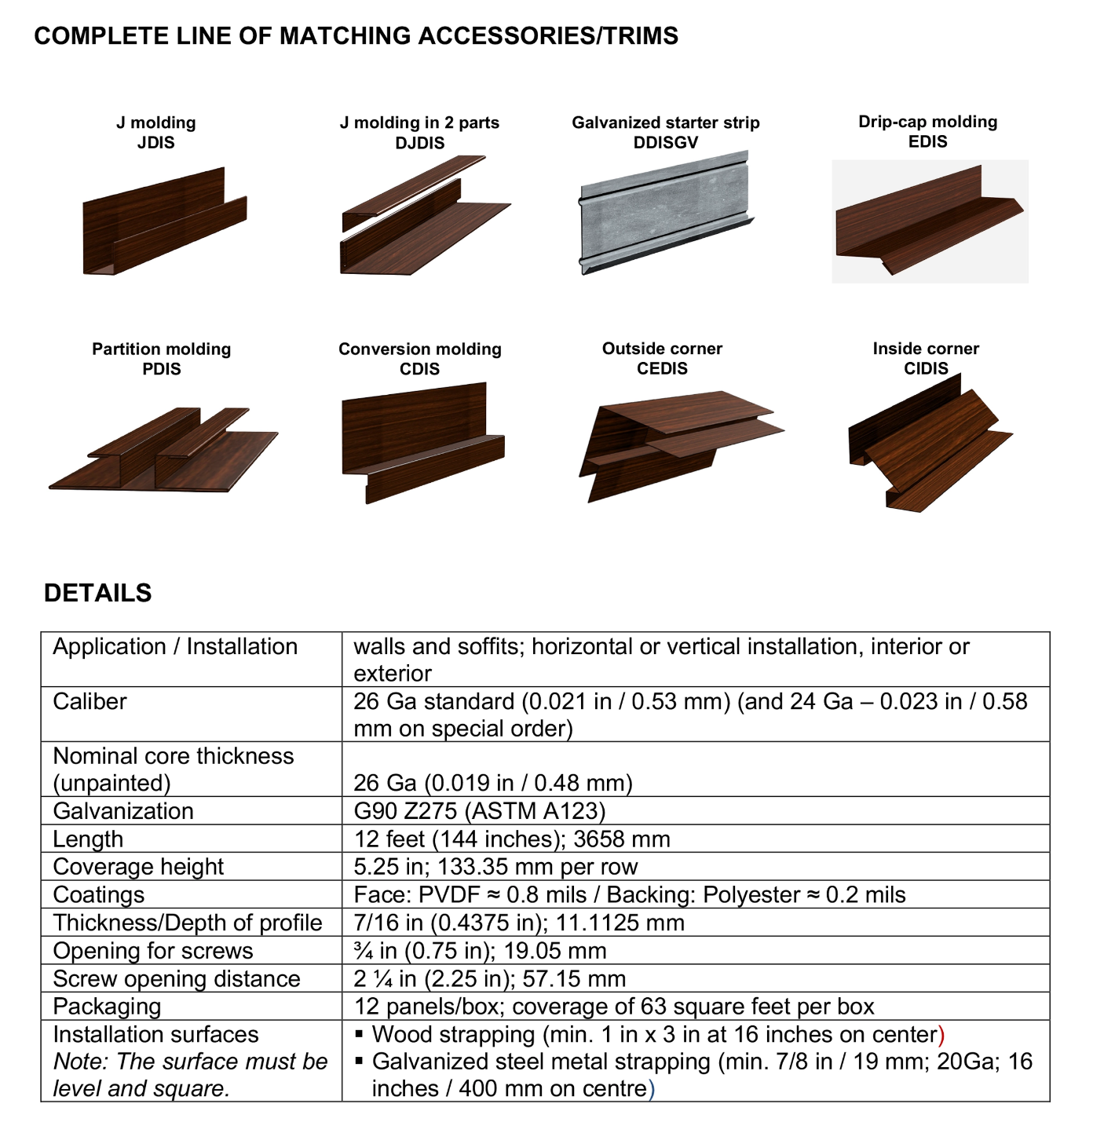

Explore Our Diverse Range of Colours and Finishes
(Greyscale & Wood Shade Series)
Each option is thoughtfully designed to not only enhance visual appeal but also withstand the challenges of harsh weather conditions, ensuring your investment stands the test of time.
Greyscale Series: The Greyscale Series presents a range of sophisticated grey tones, from light ash to deep charcoal. These versatile shades complement various architectural styles and are engineered to resist fading and weathering, preserving their elegance year after year.
Wood Shade Series: For those who appreciate the timeless beauty of wood, our Wood Shade Series replicates natural wood grains and hues with remarkable authenticity.

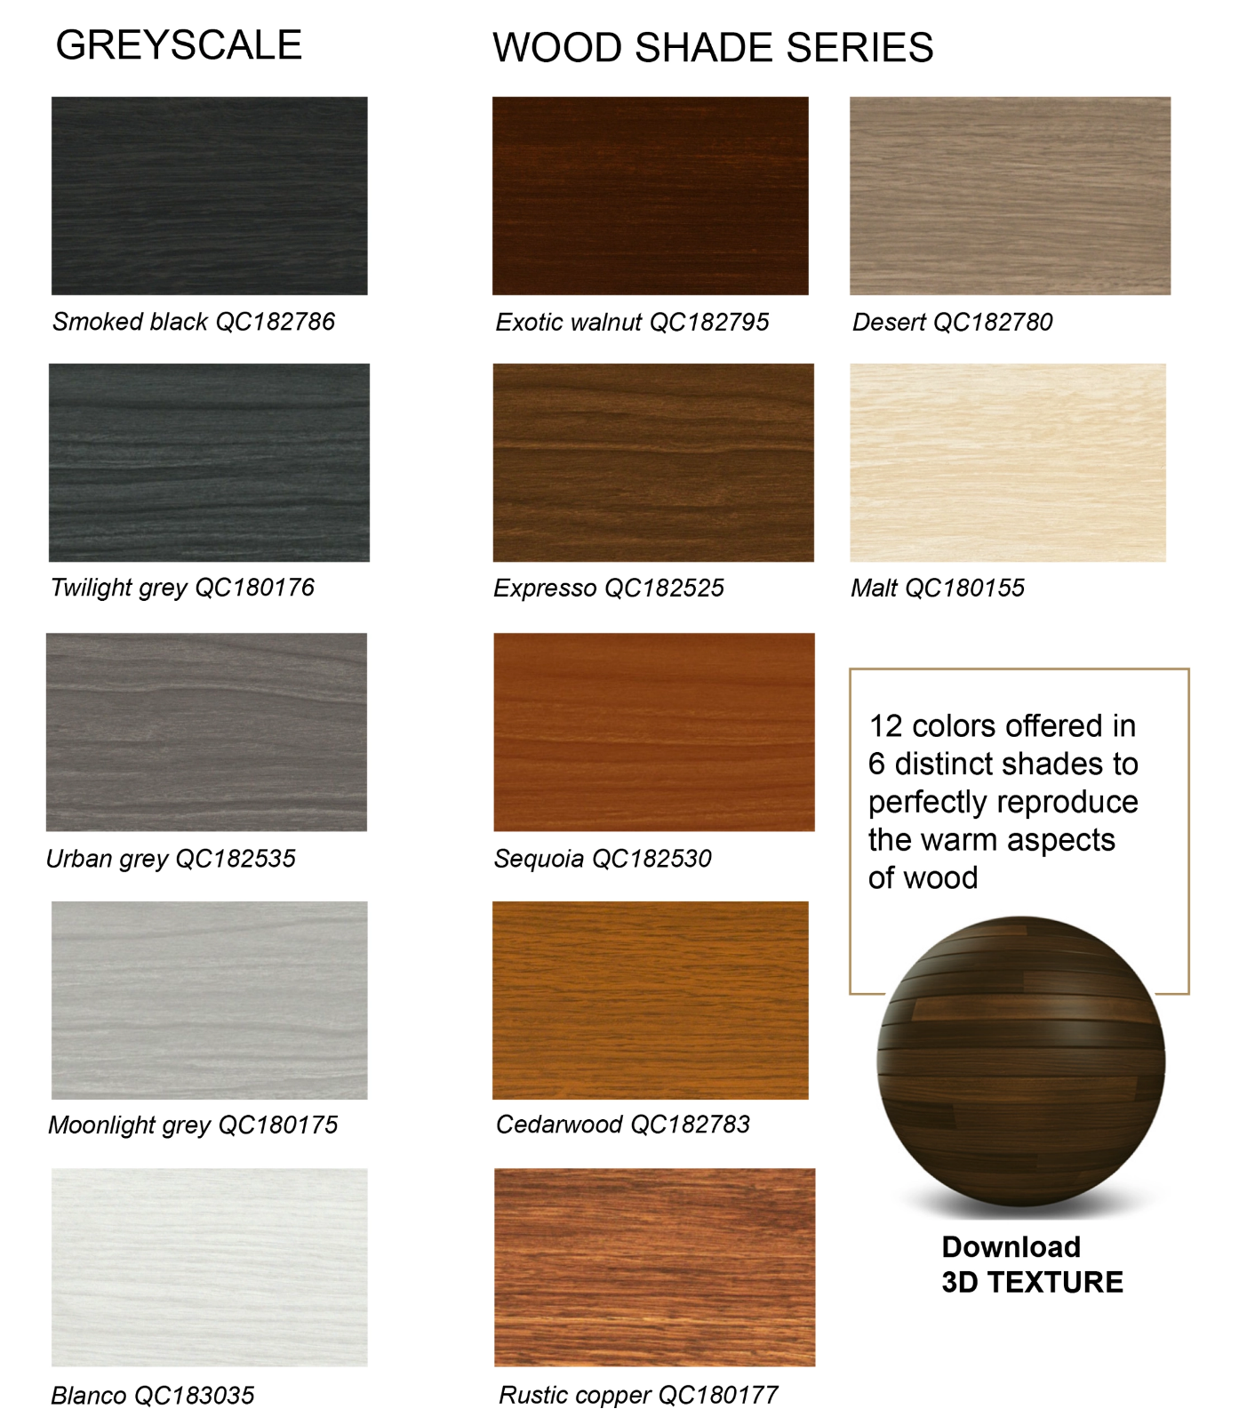

Standard and Custom Flashings
If you need a specific flashing shape, we can fabricate it. Cladcan provides a full range of flashings and trims to complete your commercial or industrial building project. From outside corners to jambs and coping flashings, we’ve got you covered.

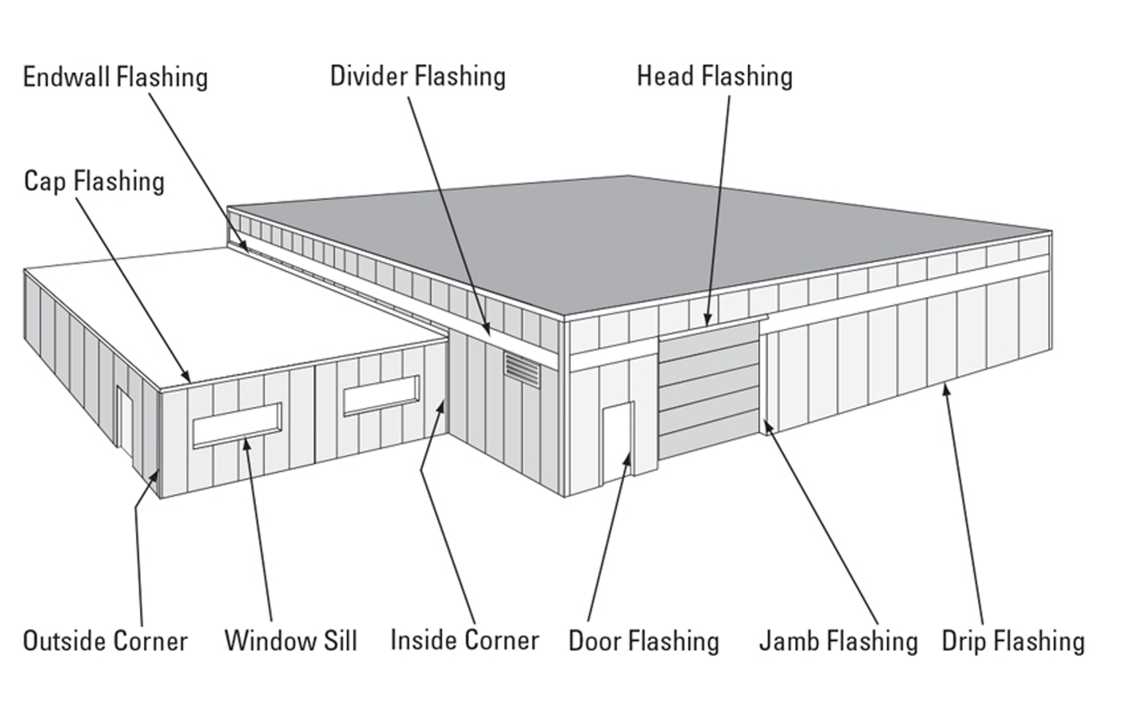

Outside and Inside Corners
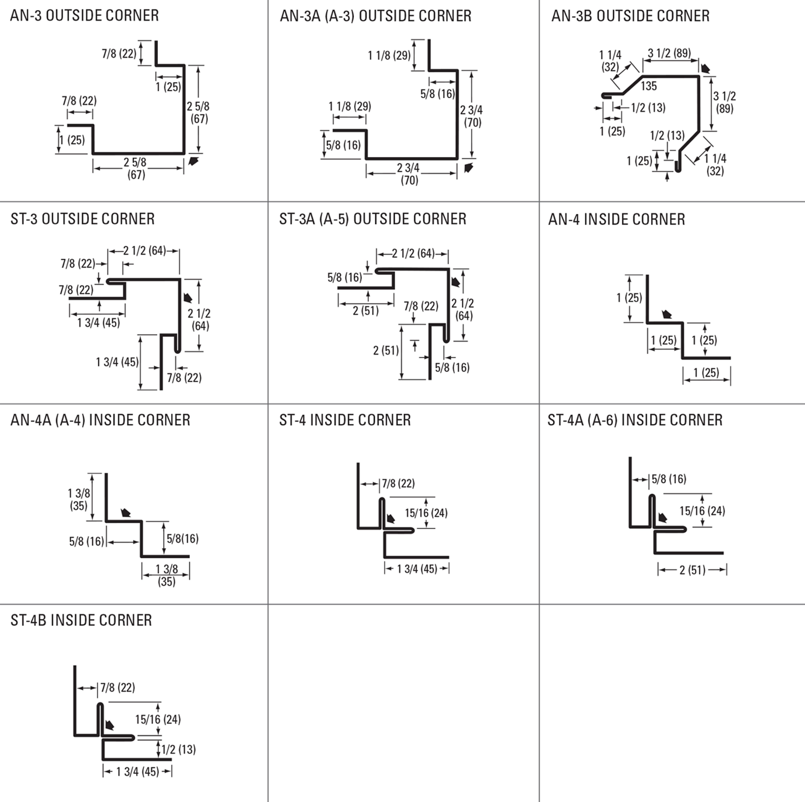

Drip and base Trims, Gable Dividers
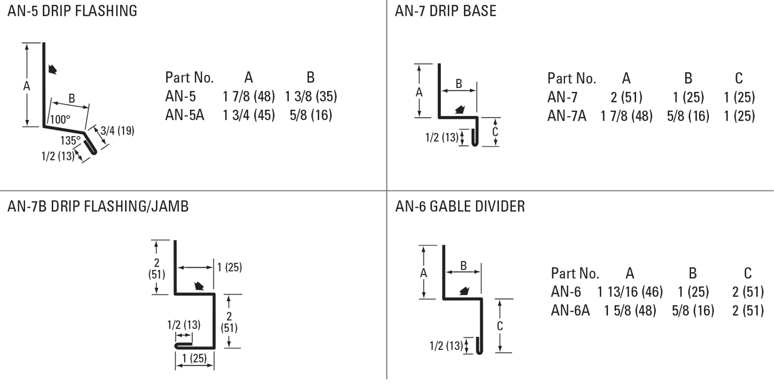
Soffit & Gable Trims, Eaves Starters, Jamb Fkashings
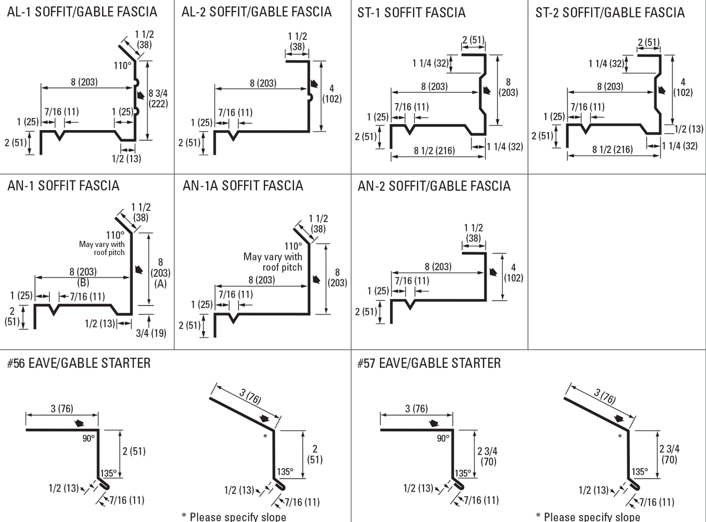
Hip Flashings, Endwalls, J-Trims, Ceiling & Sliding Door Trims
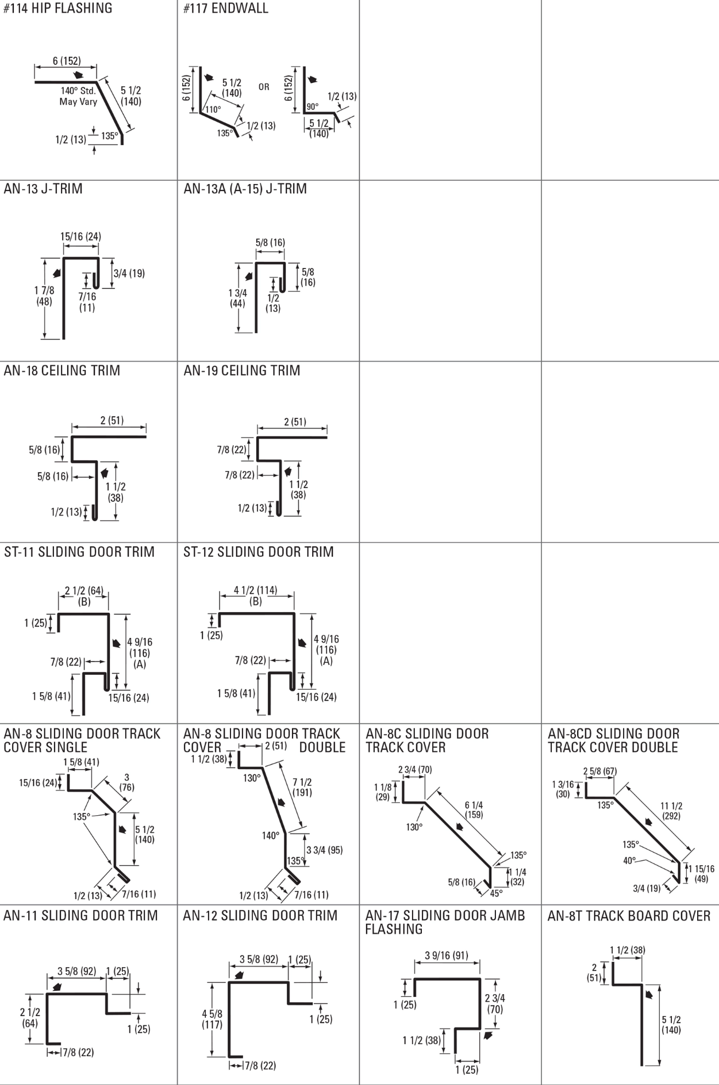
Finishes Perspectra Plus Series™
The Perspectra Plus Series™ represents the next evolution of our Perspectra Series® paint system. Enhanced with advanced Silicone Modified Polyester (SMP) technology and a new resin backbone, it offers superior resistance to chalking, fading, chemical degradation, and scratching.
Designed for maximum durability, the Perspectra Plus Series™ provides exceptional colour fade resistance, improved gloss retention, and increased scratch resistance. With a proven track record, it ensures 40 years of film integrity and 30 years of reliable colour and chalk resistance, making it ideal for roofing and cladding applications across Canada and the continental US.
Available on hot-dip galvanized steel and Galvalume™ (55% Aluminum – 45% Zinc alloy coating), the Perspectra Plus Series™ guarantees long-lasting performance and outstanding protection.

